I'm Yours - Jason Mraz Am

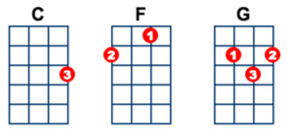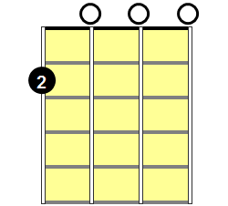
Verse 1: | C  Well, you done done me and you bet I felt it  G  I tried to be chill but you’re so hot that I melted  Am F  I fell right through the cracks, and I’m trying to get back
C
Before the cool done run out I’ll be giving it my best test
G
And nothing’s gonna stop me but divine intervention
Am F
I reckon it's again my turn to win some or learn some
Chorus: | C G  But I won't hesitate no more,  Am F  No more, it cannot wait I’m yours  Interlude: C G Am F
Verse 3: | C  Well open up your mind and see like me  G  Open up your plans and then you're free  Am F  Look into your heart and you'll find love love love love
C
Listen to the music of the moment people dance and sing
G
We are just one big family
Am F
It’s your god forsaken right to be loved, loved, loved, loved

Chorus: | C G  So, I won't hesitate no more,  Am F  No more, it cannot wait I’m sure  C G  There’s no need to complicate our time is short  Am F  This is our fate, I’m yours
Verse: | C  I've been spending' way too long checking' my tongue in the mirror  G  And bending' over backwards just to try to see it clearer  Am  My breath fogged up the glass  F  And so I drew a new face and laughed  C  I guess what I'm a saying’s there isn’t no better reason  G  To rid yourself of vanity and just go with the seasons  Am  It’s what we aim to do  F  Our name is our virtue
Chorus: 2X

Outro: | (C G Am F) C

